1. **3 Methods of enter Raspberry Pi system**
2. **PuTTY remote login**

You can remote login into the system of Raspberry Pi by PuTTY software.

(Note : This software in the Tools folder)

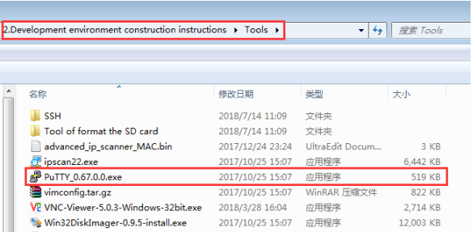

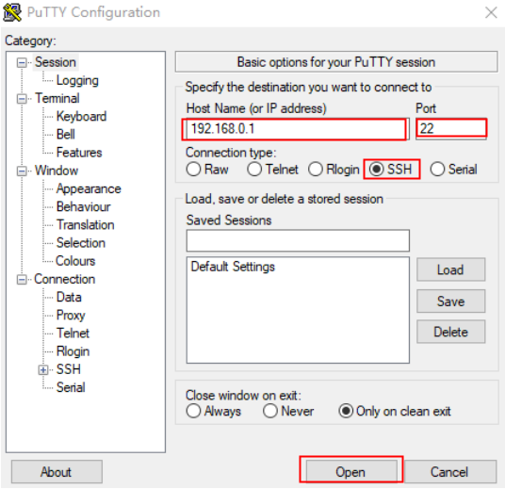

1. **VNC remote login**

VNC is also a relatively common method of logging into the Raspberry Pi system.

Official original system image of the Raspberry pi with VNC Server, but is not enabled by default. So we need to open this service by ourself.

**The following steps will teach you how to open VNC service:**

1)You need to open the command line terminal in the Raspberry Pi system and input:sudo raspi-config ,as shown in the figure below.

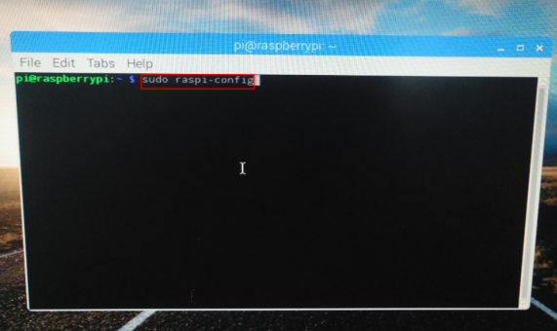

2)You should choose :5 Interfacing Options,as shown in the figure below.

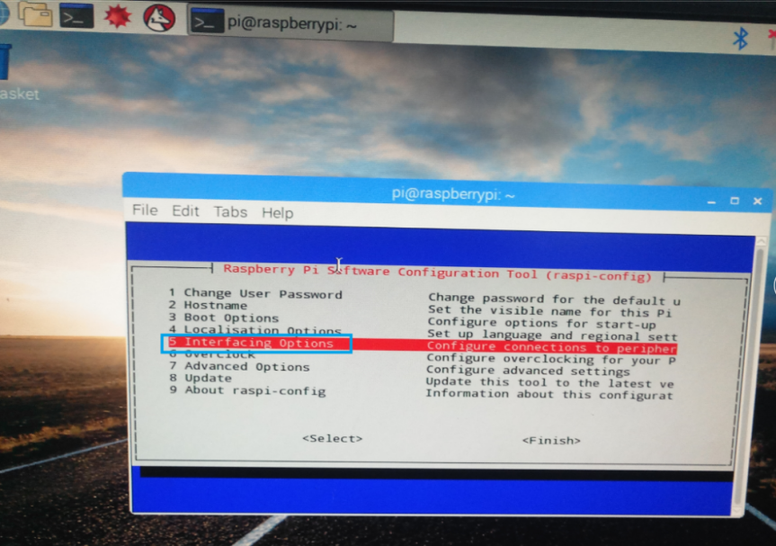

3)You should choose :P3 VNC,as shown in the figure below.

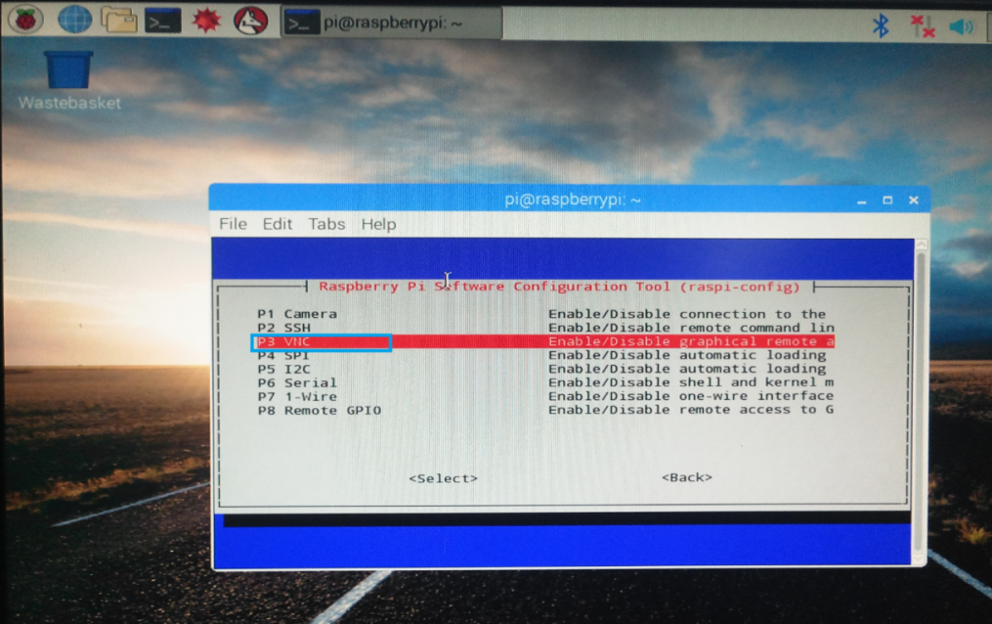

4)You should choose :Yes ,as shown in the figure below.

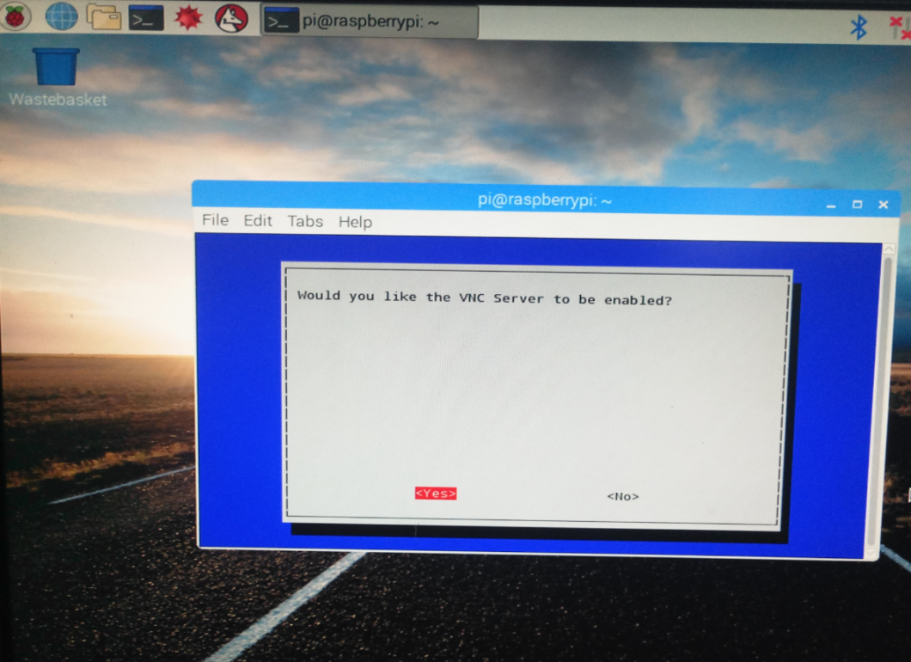

5)The interface shown in the figure below indicates that the VNC service is opened successfully.

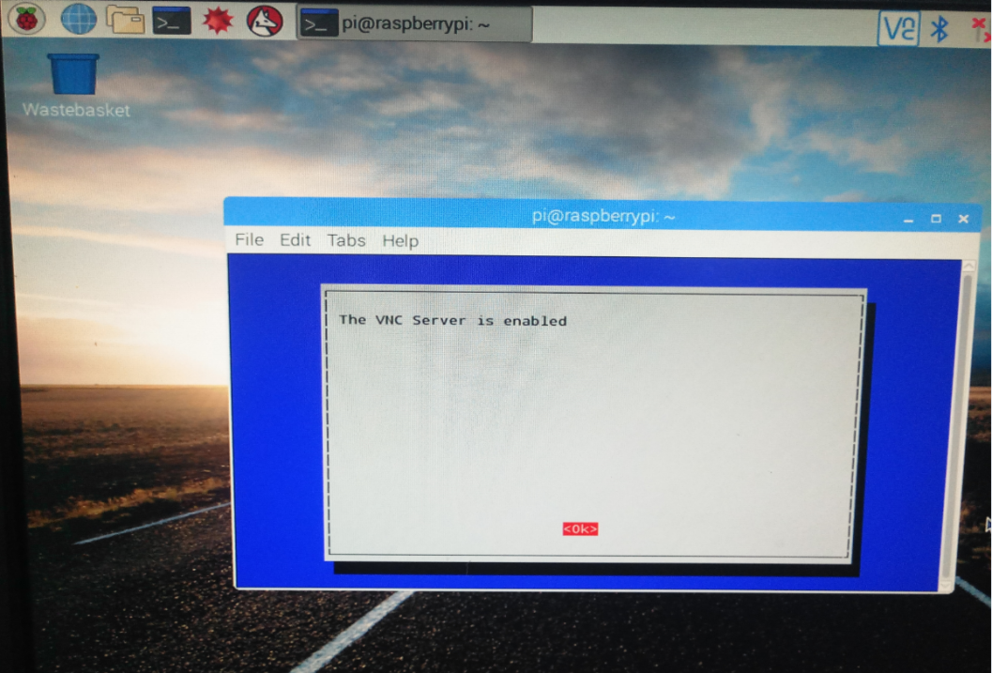

After the above steps, we have opened the VNC service successfully.

When the Raspberry Pi is turned on every time, the VNC Server will start itself. This ensures that we can remotely log into the Raspberry Pi at any time. 

**The following steps will teach you how to log into the Raspberry Pi system by VNC:**

(Note : This software in the Tools folder)

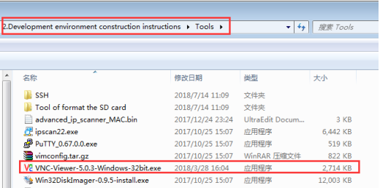

1. You need to double-click this software to use it and input the IP address of your Raspberry Pi. As shown in the figure below.

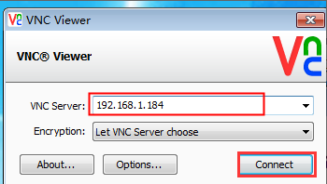

1. You need to click“Connect”and click“是”. As shown in the figure below.

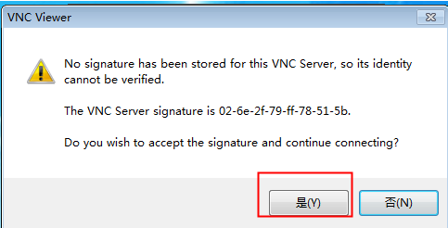

1. You need to input Username and password.

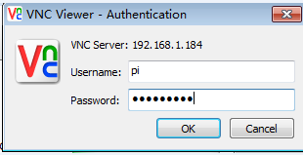

1. When the connection is successful, you will see the remote desktop of the raspberry pi. As shown in the figure below.

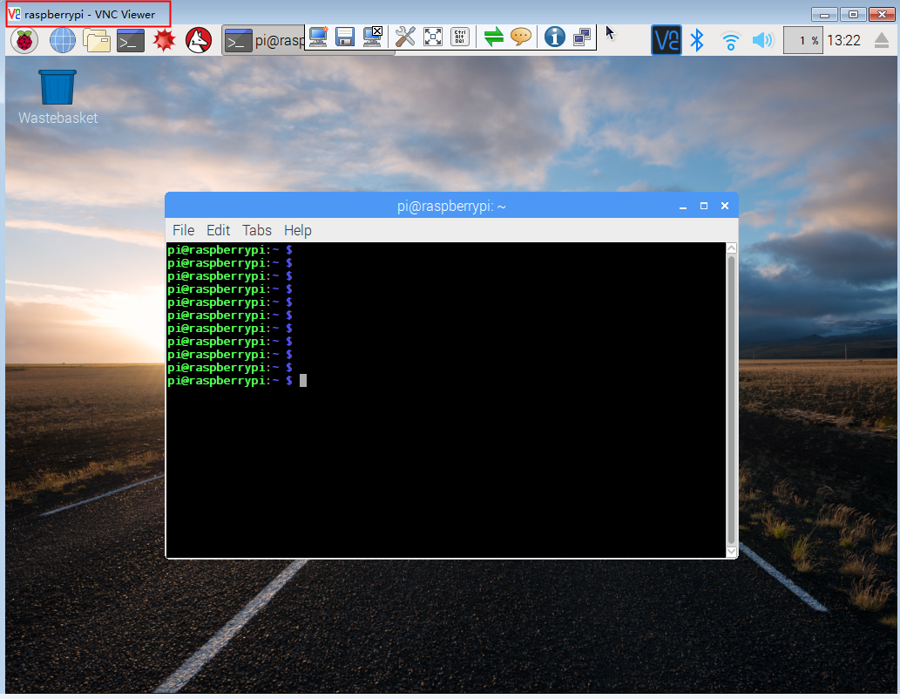

1. **SSH remote login**

**The following steps will teach you how to log into the** **Raspberry Pi system by SSH Secure Shell Client:**

(Note : This software in the SSH folder)

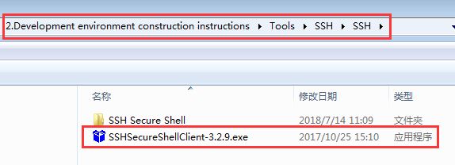

1)You need to input Host name, User name, Port. As shown in the figure below.

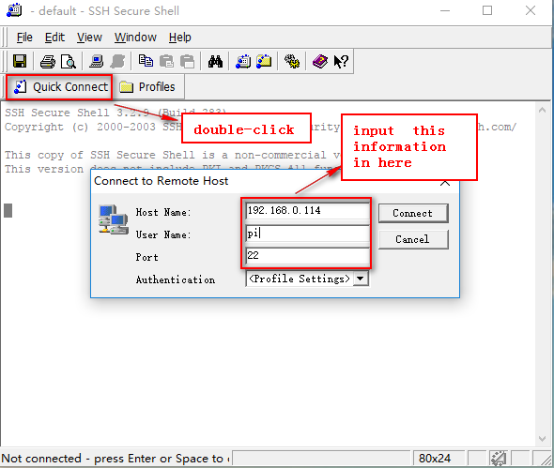

2)If the system prompts this error: server responded “algorithm negotiation failed”

We need to enter Raspberry Pi system by PuTTY and modify the ssh configuration file.

You should input: **sudo vi /etc/ssh/sshd_config**

Add the following code:

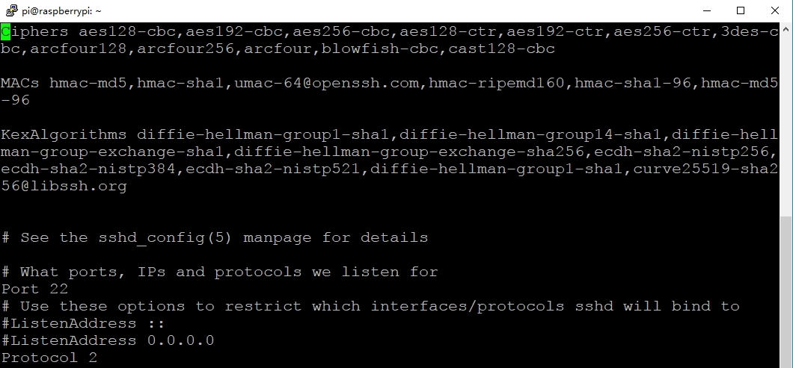

Ciphers aes128-cbc,aes192-cbc,aes256-cbc,aes128-ctr,aes192-ctr,aes256-ctr,3des-cbc,arcfour128,arcfour256,arcfour,blowfish-cbc,cast128-cbc

MACs hmac-md5,hmac-sha1,umac-64@openssh.com,hmac-ripemd160,hmac-sha1-96,hmac-md5-96

KexAlgorithms diffie-hellman-group1-sha1,diffie-hellman-group14-sha1,diffie-hellman-group-exchange-sha1,diffie-hellman-group-exchange-sha256,ecdh-sha2-nistp256,ecdh-sha2-nistp384,ecdh-sha2-nistp521,diffie-hellman-group1-sha1,curve25519-sha256@libssh.org

(Note:After the input is complete, you need to save it)

1. You need to input **sudo service ssh restart.** This command is to restart the ssh service.

You also input **sudo /etc/init.d/ssh restart.** This command is to restart the ssh service too.

5)Then we continue to log in:

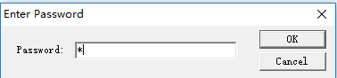

6)The following interface appears to indicate login successfully.

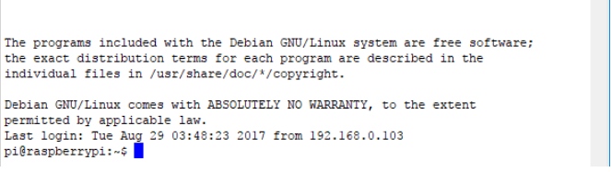

**How to change the pi account password and start the root account**

As shown in the figure below.

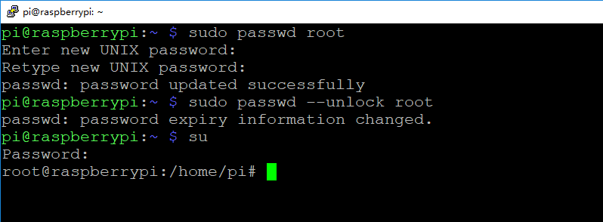

This allows the root user to unlock successfully.